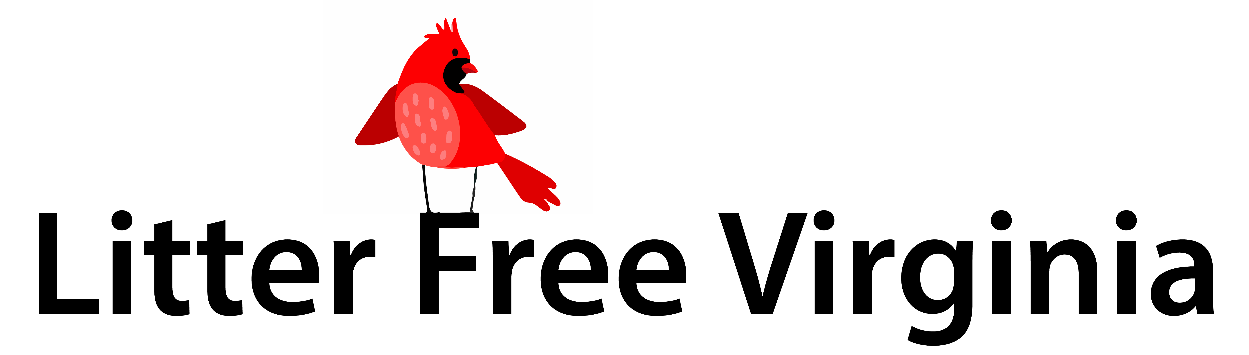

October 15, 2018 (CHANGE DATE)

To The Virginia General Assembly,
On behalf of ___________________, we write to request your support for legislation on disposable bags (especially plastic bags), which will help to clean up Virginia’s fields, streams and cities.

Potential legislation to consider:
- Local Option Bag Fee – Local governments have the option to establish a fee (typically $0.10) on disposable bags provided by retail stores. “Disposable bag” means a bag of any material, commonly plastic or kraft paper, which is provided to a consumer at the point of sale to carry purchases. Funds from said fee would be returned directly to retailers or flow into programs for litter prevention, reduction and environmental education.
- Adjust Litter Tax for Inflation – Virginia’s Litter Tax (§ 58.1-1707), established in 1977, is woefully underfunded. Currently, businesses must pay $10 per business location, and an additional $15 for each location that manufactures, sells, or distributes groceries, soft drinks, or beer. This tax should be adjusted for decades of inflation so that localities have sufficient funds to combat litter issues through education and programming.

It’s important to note that litter is not only an environmental problem – it’s also an economic problem. Virginia spends millions of dollars a year cleaning up litter on the taxpayers’ dime. Furthermore, an unhealthy Bay endangers local fishing and tourism industries. No one wants to tan on a littered beach. Cotton farmers loathe plastic bags because bags catch in the gin and contaminate entire bales. Finally, retailers save when they are no longer expected to provide single-use bags free of charge!

We appreciate your willingness to lead on this issue. Go to LitterFreeVA.org for more information.

Sincerely,
Your Name
Your Address
Your phone number and/or email address

